Title:
Day 10

Opener:
Please describe, in four sentences or less, what you remember about enzymes and their activity.

Length of Time:
1 class period between 45-50 minutes

Environment: The classroom desks will be in straight rows. Most of the time, students will be working in the lab.

Standards:
B.1.1 Describe the structure of the major categories of organic compounds that make up living organisms in terms of their building blocks and the small number of chemical elements (i.e., carbon, hydrogen, nitrogen, oxygen, phosphorous and sulfur) from which they are composed.

B.1.2 Understand that the shape of a molecule determines its role in the many different types of cellular processes (e.g., metabolism, homeostasis, growth and development, and heredity) and understand that the majority of these processes involve proteins that act as enzymes.

Objectives:
Students will be able to model the action of an enzyme and explain its importance in biofuel production. Groups will model the effect of temperature and pH on enzymatic action.

Procedure:
Students will complete the day’s opener (5 minutes).
Teacher will briefly explain procedure of lab explaining that half the group will test pH and the rest temperature (5 minutes).
Students will begin testing the effect of pH and temperature on an enzyme’s activity (30 minutes).
Discuss final assessment piece covering rubric for tool (5 minutes).
Students will complete the exit question (5 minutes).

Materials:
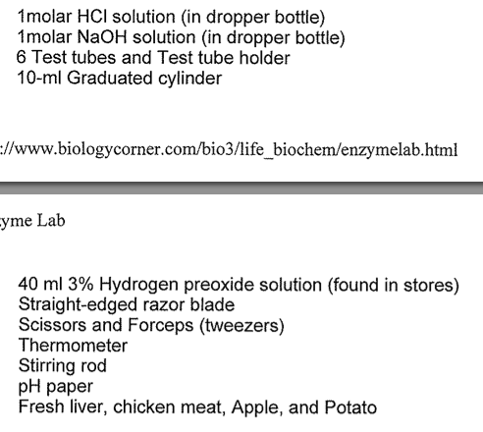
Exit Question:
How does what you learned today about enzymes apply to biofuel production?
Assessment
Exit question and starting final assessment piece.

